Exercise Log
Max HR (MHR = 220 – age):______
Resting HR (RHR):______
Target HR (THR = (MHR – RHR) x.04+RHR):______
Day: Sun Mon Tue Wed Thu Fri Sat
Sleep (7-8hrs): _____hrs
Calories (daily calories intake):______

Name: ___________________________
Current Weight: _____lbs _____kg
Goals: ___________________________
Starting Date: ____ / ____ / ____

Date | Exercises (what)  activity | Weight (lbs) | Sets  (how much) | Time (how long) minutes | Rest  (minutes) | Stretch before/after |  | Calories Burned | Notes
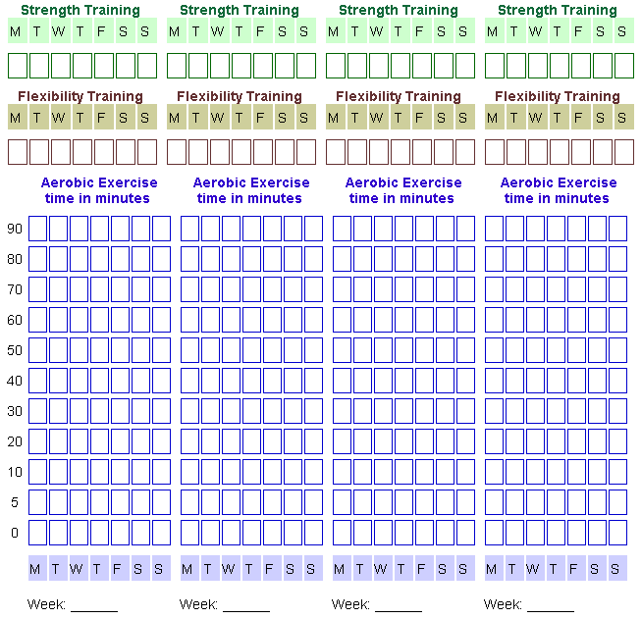
Notes:
________________________________________________________________________________________________________________________________________________________________________________________________________________________________________________________________________________________________________________________________________________________________________________________________________________________________________________________________________________________________________________________________________________________________________________________________________________________________________________________________________________________________________________________________________________________________________________________________________________________

